How to add a disk on your virtual machine:

1. Click on the target virtual machine

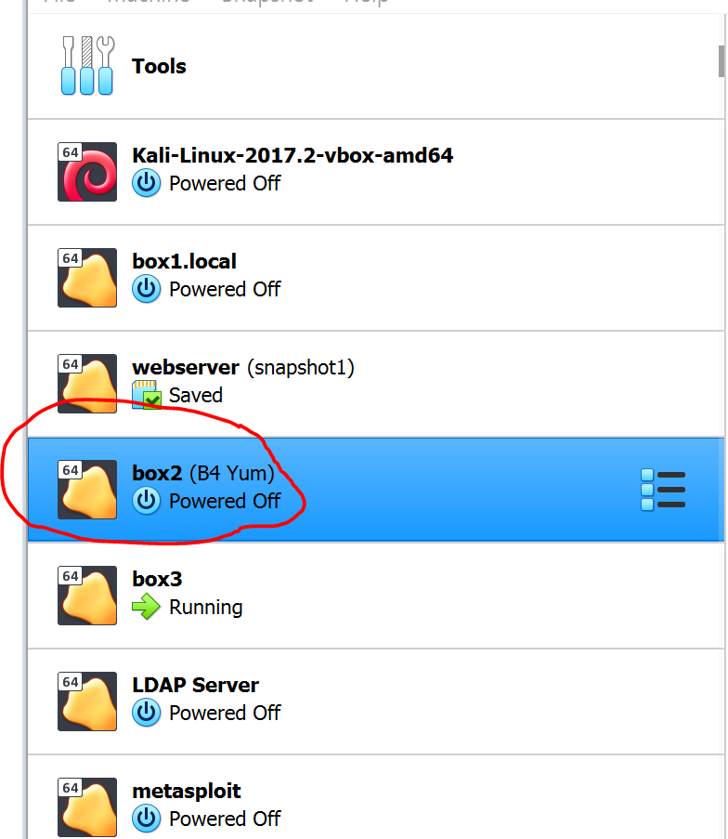

1. Click Settings:

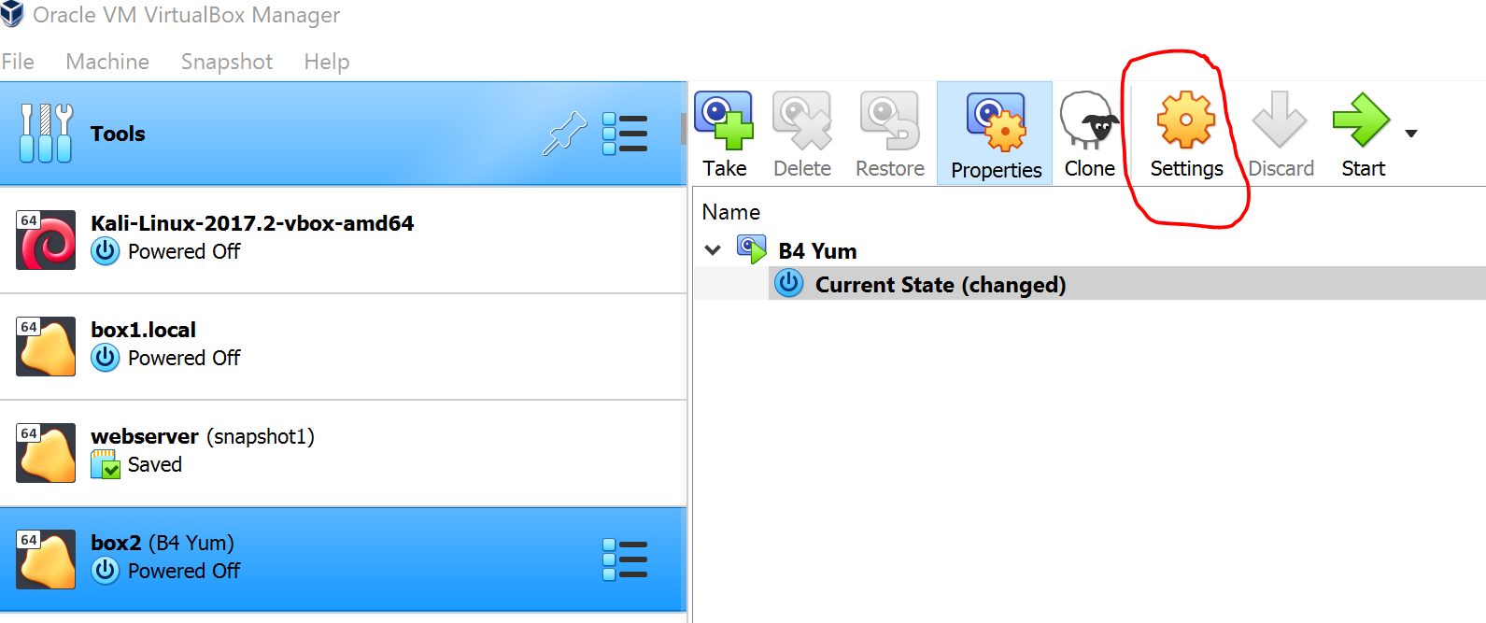

Click Storage then the disk icon below then click hard disk

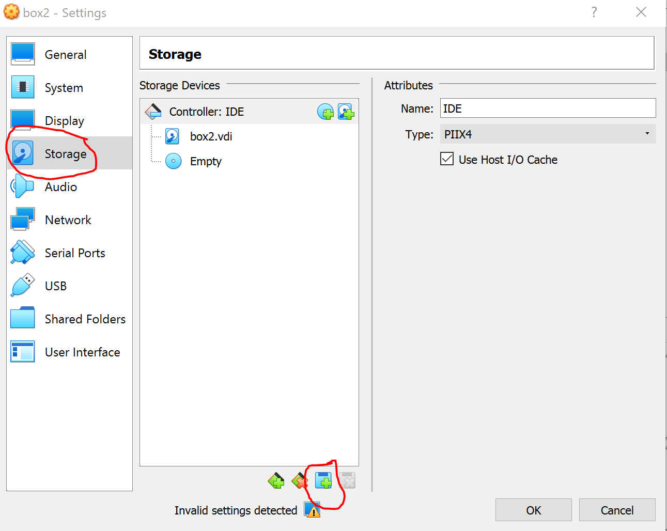

Click Create:

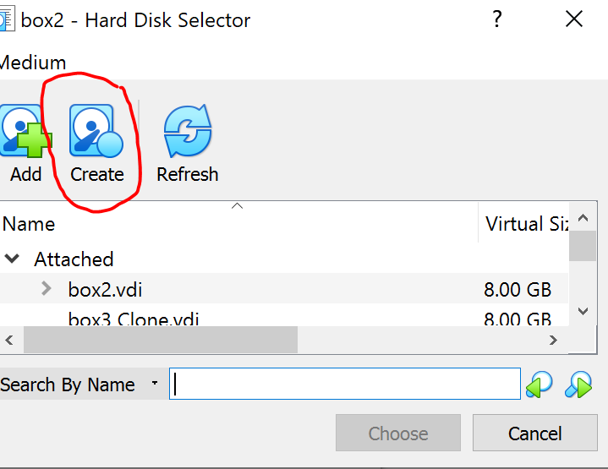

Adjust the file size to the desired size. Default is 8.00 GB.

You can also change the file location and name

Then click create:

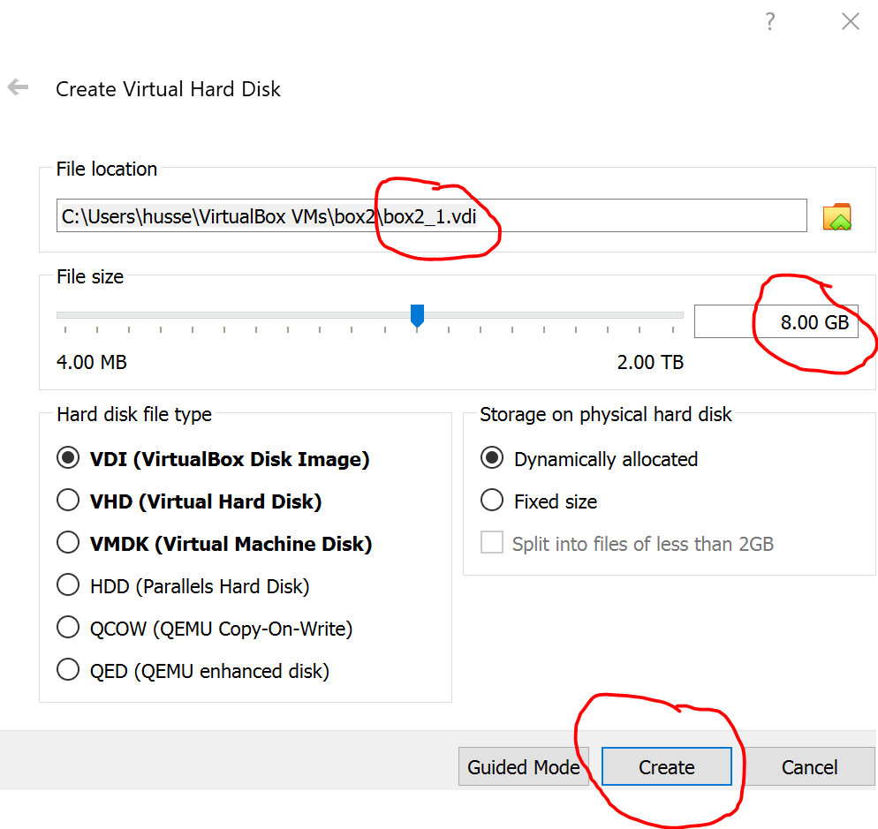

Click the disk then click choose

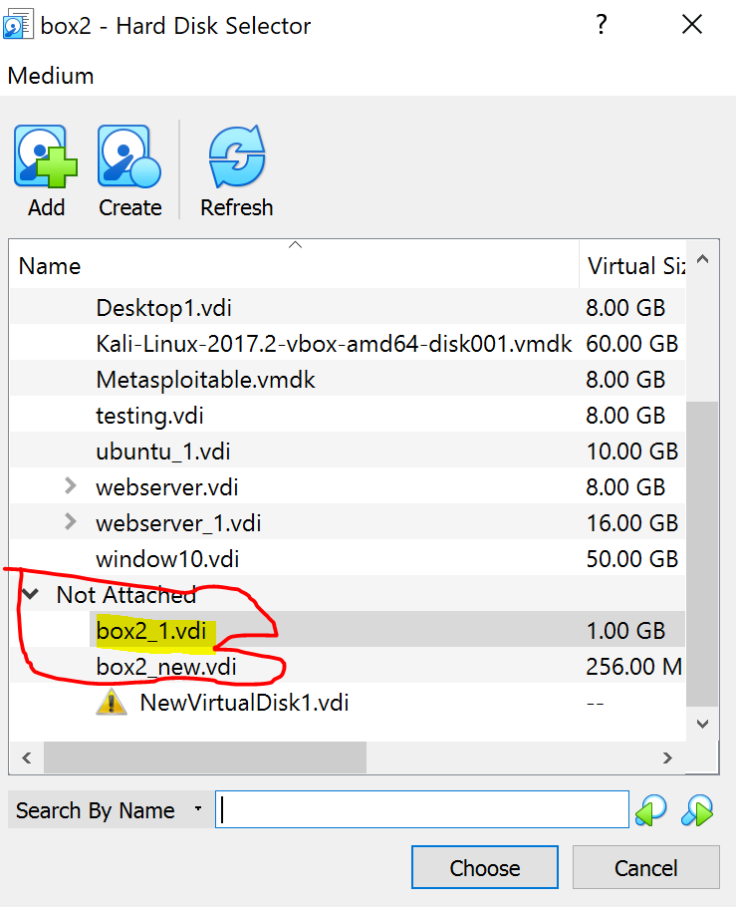

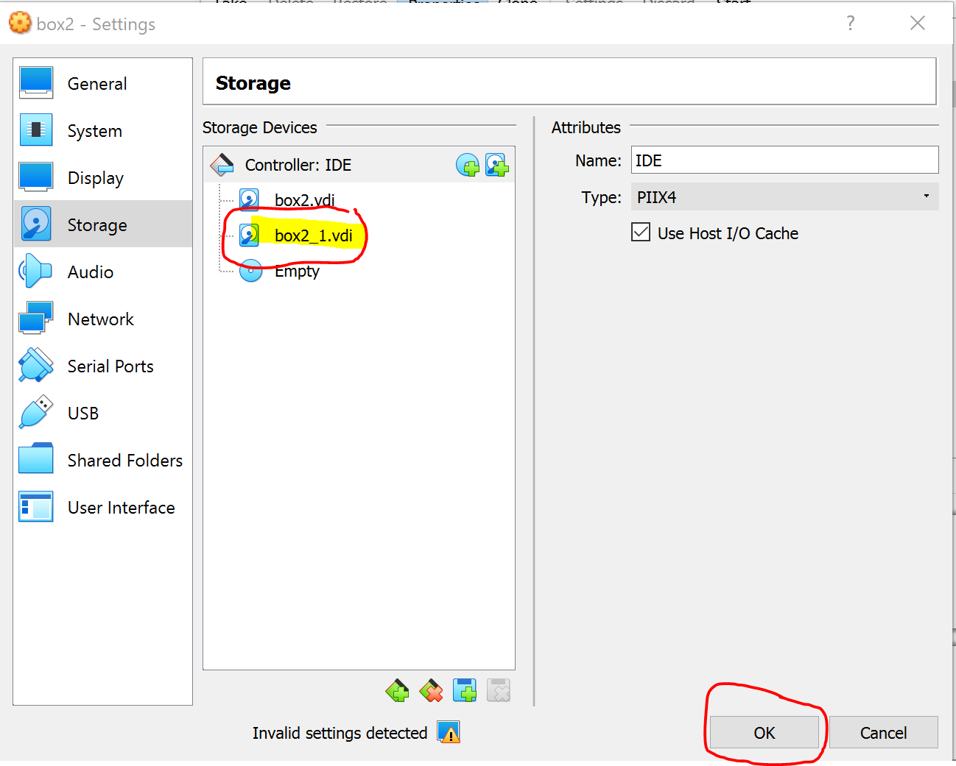

Restart the VM